SIMATS ENGINEERING (SAVEETHA SCHOOL OF ENGINEERING)
Department of Computer Science and Engineering

ASSESSMENT TOOL 1 – Concept Mapping Questions

Course Code: | CSA0303 | Course Title: | Data Structures
CO Assessed: | CO1 | Assessment: | Assessment Tool 1 – Concept Mapping Questions
Weightage: | 10% of CIA | Total Marks: | 100
CO1 Statement: | Basics, Data, Data object, Data structure, Abstract Data Types (ADT), realization of ADT in ‘C’, Primitive and non-primitive data structure, Linear and non-linear data structure Arrays & Recursion, Performance analysis and Measurement: Time and space analysis of algorithms, Average, best and worst-case analysis.
Student Name: | SK.AKHIL AHAMMED | Reg. No.: | 192572114
Section / Batch: | 2025 | Date:

Code of Conduct
I __________________________ (Name / Reg No) certify that this submission is my original work and that I have adhered to the guidelines specified for this assessment. I understand that any violation of academic integrity rules will result in disciplinary action.
Signature of the Student: _________________________

Instructions
- This test contains 3 Concept mapping questions. Total: 100 Marks.
- When a student answer using a concept map, in evaluation the answer should contain following four requirements: Understanding of concepts, Connections between ideas, Logical structure, Clarity of representation.
- No negative marking. Unanswered questions carry zero marks.
- No DTP printouts or electronic devices permitted. They should provide written materials.

Section / Topic | Focus | Q Nos | Marks
Basics, Data, Data object, Data structure, Abstract Data Types (ADT), realization of ADT in ‘C’ | Concept mapping on classifications of data structures. | 1 | 30
Performance analysis and Measurement: Time and space analysis of algorithms, Average, best and worst-case analysis. | Linear and Binary search | 2 | 40
Primitive and non-primitive data structure, Linear and non-linear data structure Arrays | Linked List | 3 | 40
GRAND TOTAL: |  | 100 Marks

Annexure A – Concept mapping questions
1) A smart city traffic management system handles data related to vehicle movement, road networks, and signal control. Construct a concept map connecting Primitive Data Structures → Non-Primitive Data Structures → Linear → Non-Linear

01

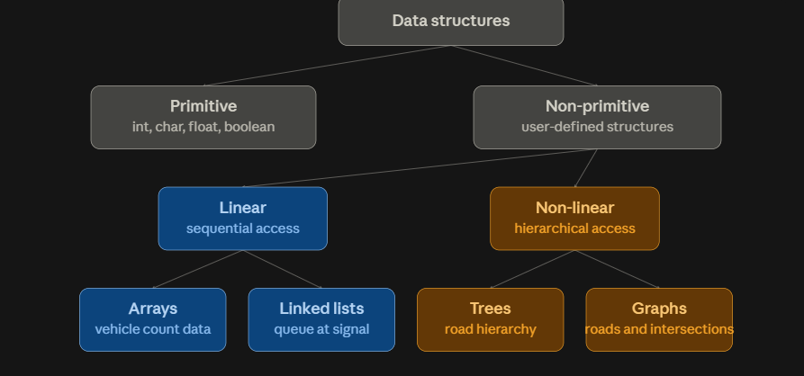

02

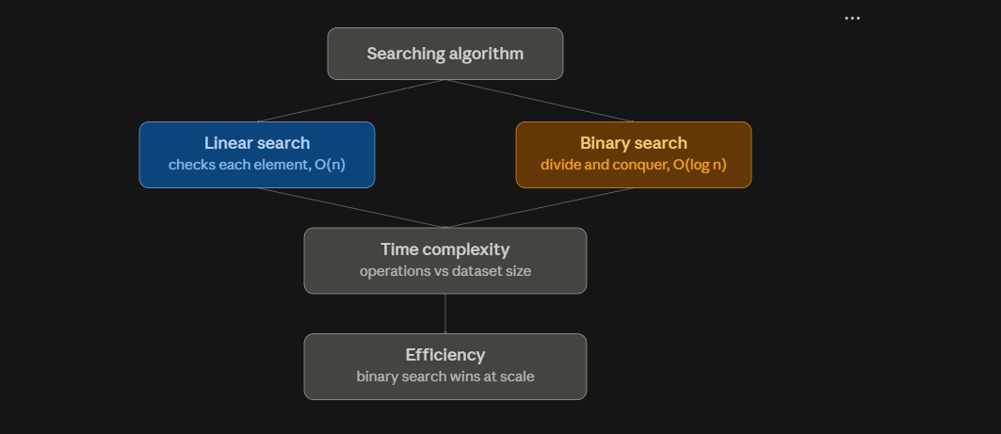
03

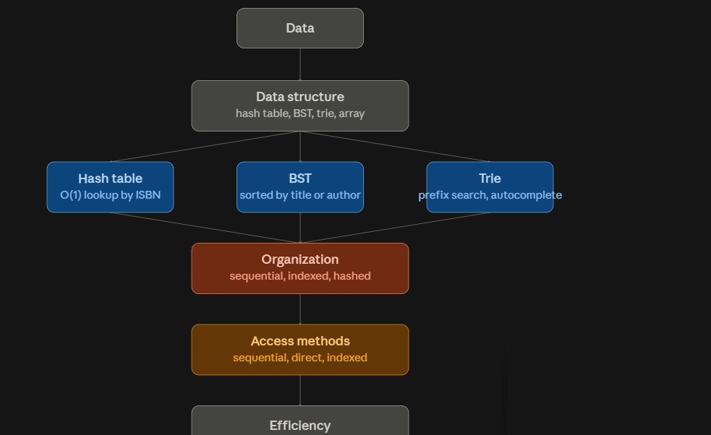

Structures. Include examples such as arrays, linked lists, trees, and graphs, and illustrate their applications in traffic management. Explain the relationships between these structures and justify their classification based on functionality and efficiency.
2) A system needs to search for specific records in a large dataset efficiently. ]Construct a concept map linking Searching Algorithm → Linear Search → Binary Search → Time Complexity → Efficiency. Include relationships that compare the
number of operations and performance of each method. Analyze which algorithm is more efficient and justify your conclusion.
3)A library management system stores thousands of book records including title, author, and availability status. Construct a concept map linking Data → Data Structure → Organization → Access Methods → Efficiency. Include different data structures used for storing and retrieving records. Explain how proper organization improves search efficiency and system performance.

Rubrics for Calculation
Criteria | Weightage | Level 4 – Exemplary | Level 3 – Proficient | Level 2 – Developing | Level 1 – Beginning
Understanding of Problem Context | 20 | Clearly understands the problem and accurately identifies all requirements | Good understanding with minor gaps | Basic understanding; some requirements unclear | Poor understanding or misinterpretation of the problem
Application of Concepts | 30 | Accurately applies appropriate concepts to solve complex problems | Applies relevant concepts correctly with minor errors | Applies basic concepts with limited accuracy | Fails to apply appropriate concepts
Problem-Solving Approach | 20 | Logical, well-structured, and efficient approach | Mostly logical approach with minor gaps | Basic approach with some inconsistencies | Illogical or unclear approach
Accuracy of Solution | 20 | Completely correct solution with proper justification | Mostly correct with minor errors | Partially correct solution | Incorrect or incomplete solution
Clarity | 10 | Clear, well-organized, and properly explained solution | Understandable with minor clarity issues | Limited clarity and explanation | Poorly presented and difficult to understand

Faculty In-charge | Course Coordinator | Program Director
Signature: _______________ | Signature: _______________ | Signature: _______________
Date: ___________________ | Date: ___________________ | Date: ___________________

